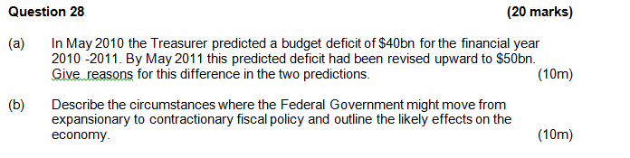
Question 26 (12 marks)

Contributions to Growth 2012-13
(Treasury’s forecast for 2012-13)

Source: www.treasury.gov.au

(a) (i) The economic growth rate expected for 2012-2013 is __________ (1 mark)

(ii) The largest contributor to economic growth is expected to be __________. (1 mark)

(b) In 2011-12 business investment increased by 5.6%. Explain two possible reasons for the forecast larger increase in business investment in 2012-13. (4 marks)
_______________________________________

______________________________________

(c) Using data from the graph, comment on expected economic activity in the Australian economy over the next few years. (6 marks)
_______________________________________

_______________________________________

_______________________________________

_______________________________________

_______________________________________

_______________________________________
_______________________________________

_______________________________________

_______________________________________

_______________________________________

Question 29 (20 marks)

(a) In September 2012, as a result of plummeting iron ore prices, Fortescue Metals Group and BHP shelved expansion plans in the North West totalling approximately $22 billion.

Using a diagram(s), demonstrate and explain how this decision by mining firms could have a multiplied effect on economic activity in Australia. (12 marks)

(b) Explain reasons for the slowdown in growth of consumption and investment in recent years. (8 marks)

Question 26 (12 marks)

(a)(i) The economic growth rate expected for 2012-2013 is __________. (1 mark)

Description | Marks
3% | 1
Total | 1

(a)(ii) The largest contributor to economic growth is expected to be __________.(1 mark)

Description | Marks
Business investment | 1
Total | 1

(b) In 2011-12 business investment increased by 5.6%. Explain two possible reasons for the forecast larger increase in business investment. (4 marks)

Description | Marks
High prices for iron ore/coal →↑I to take advantage of higher profits.  Change in MEC/ir ratio eg improved business confidence.  Decrease in ir, thus higher profit →↑I. Example required.  Other eg technology change | 2  2  2  2
Total | 4

(c) Using data from the graph, comment on expected economic activity in the Australian economy over the next few years. (6 marks)

Description | Marks
GDP and Business Investment indicate increased activity (output, spending, Y and N).  Budget surplus (-ve public spending) is indicative of a growing economy.  Low C growth may be due to higher savings and thus lower activity in the future.  Low (non-existent) dwelling I (leading indicator) indicates future fall in activity  Other eg two-speed economy | 4  2  2  2  2
Total | 6

